Lab-4

Demonstration of Unix Commands: ln, nl, head, tail, sort, ƒind, uniq, tr, history, pipe, write, wall Part:

A 1. Perform the following Unix Commands: ln, nl, head, tail, sort, ƒind, uniq, tr, history, pipe, write, wall

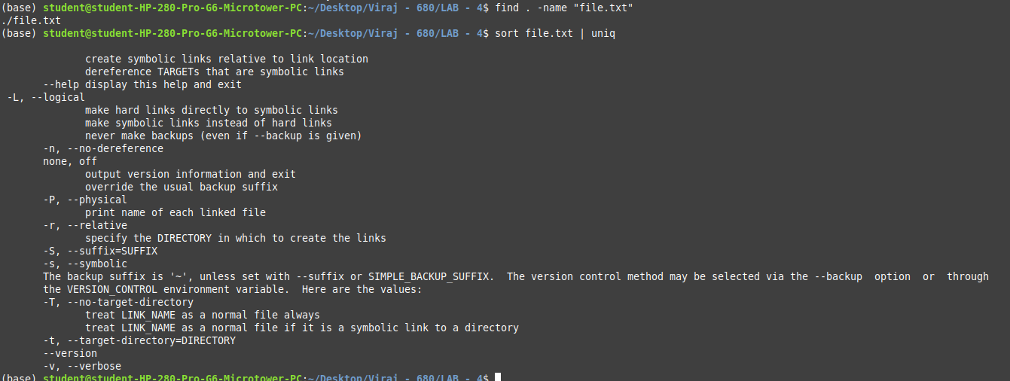

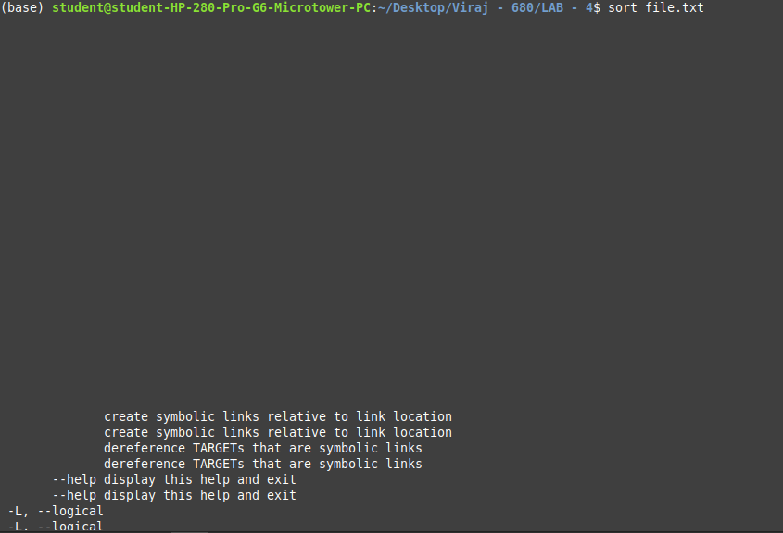

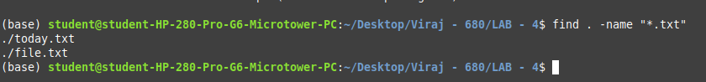

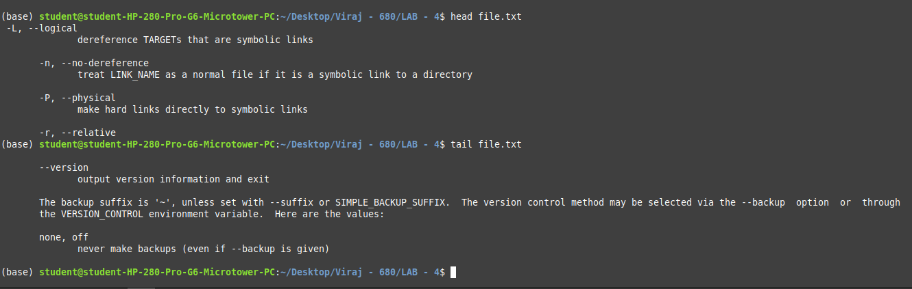

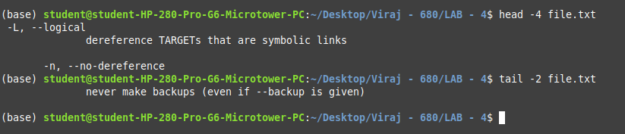
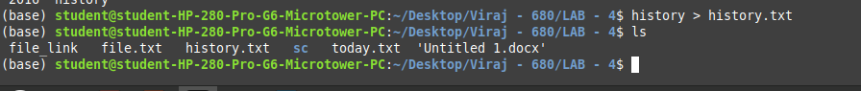

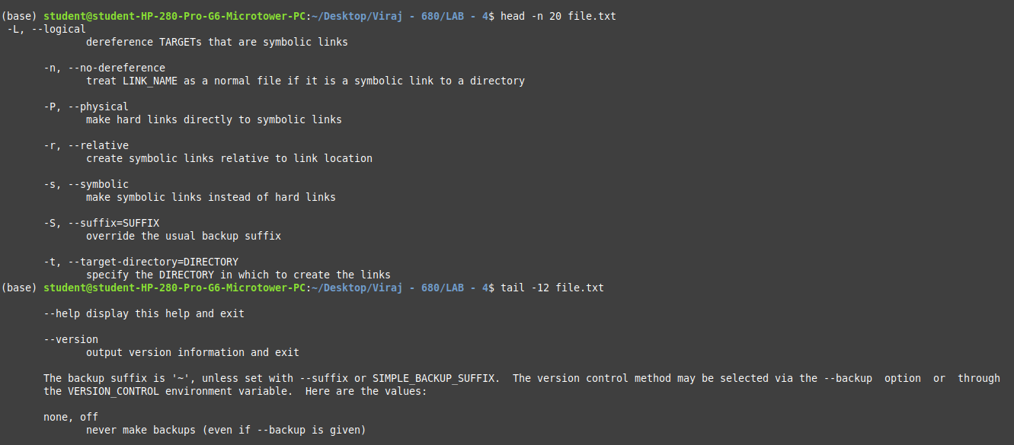

Part: B

1. Create a hard link named file_link to a file file.txt, then display the first 10 lines of file.txt with line numbers.

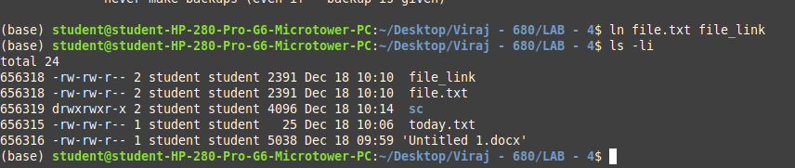
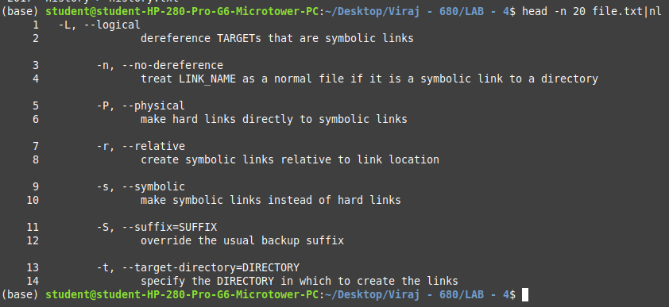

2. Display the last 20 lines of log.txt, sort the lines, and remove duplicate entries.
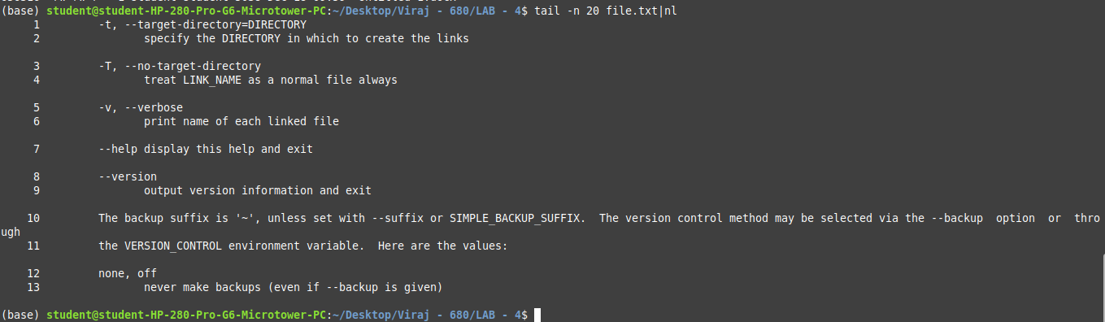

3. Find all .txt files in the current directory, display the first 5 lines of the search result, and send the result to user john using write.

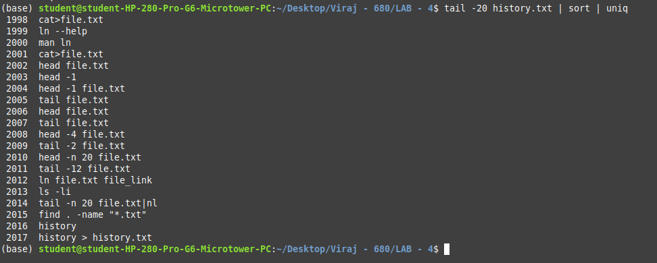

4. Display the last 10 commands from the command history and broadcast them to all logged-in users.

And
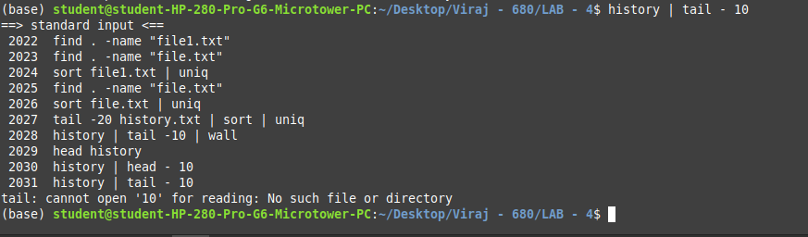

5. Add line numbers to the file data.txt, then sort the lines and remove duplicates.

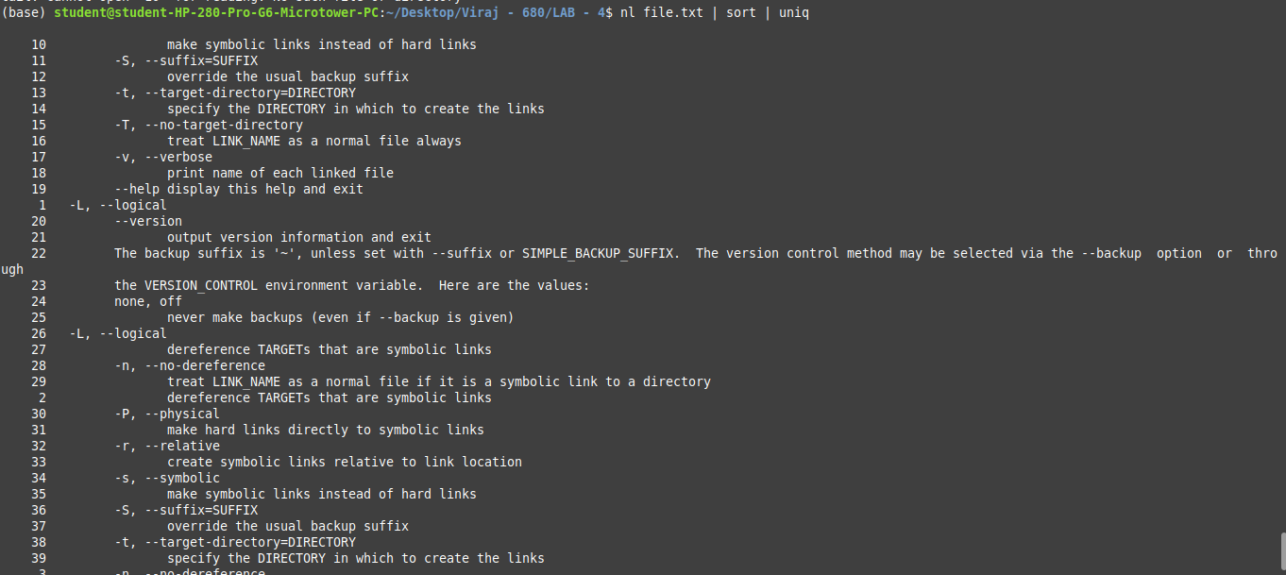

6. Create a symbolic link dir_link to a directory mydir, then find all .sh files in the directory and broadcast the result to all users using wall.

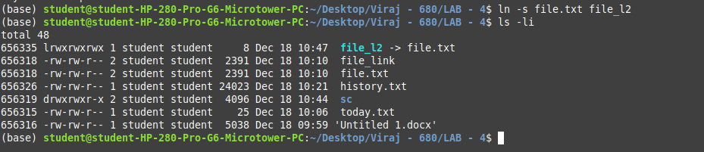

7. Display the first 5 lines and the last 5 lines of file.txt.

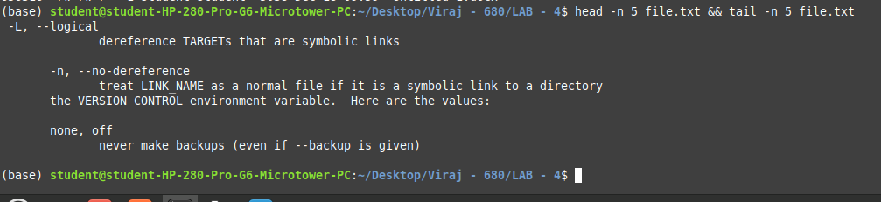

8. Find all .log files, sort them alphabetically, and remove duplicates if any.

Part: C

1. Display the first 10 lines of input.txt, translate all lowercase letters to uppercase, and add line numbers.

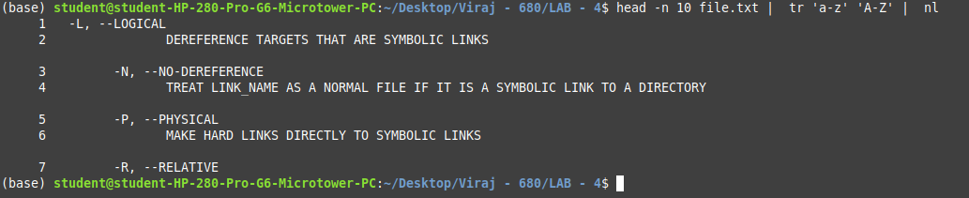

2. Create a symbolic link log link to the file logfile.txt, display the last 50 lines of logfile.txt, and remove duplicates.

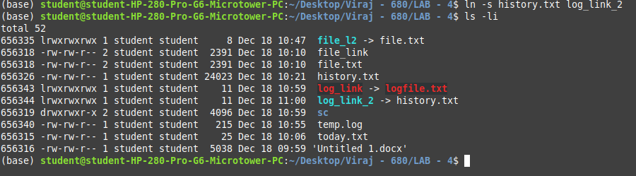
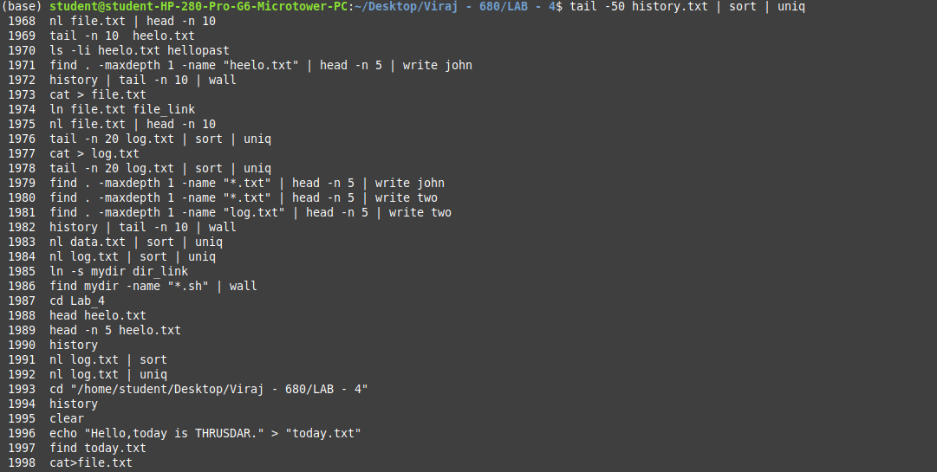

3. Add line numbers to file.txt, then display the first 15 lines and sort them in reverse order.

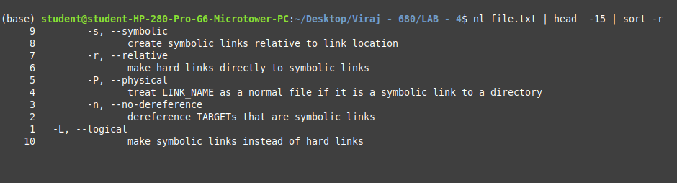

4. Remove duplicate lines from data.txt, convert all spaces to underscores.

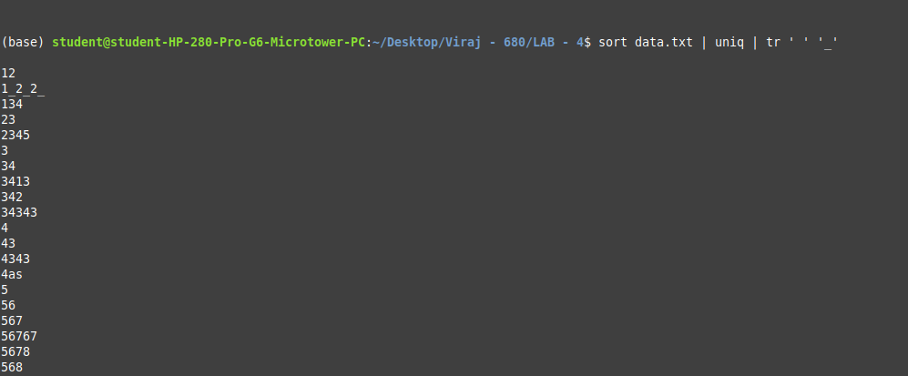

5. Sort the lines in records.txt, remove duplicates, and count the number of unique lines.

6. Search your command history for all occurrences of chmod, then remove duplicates.

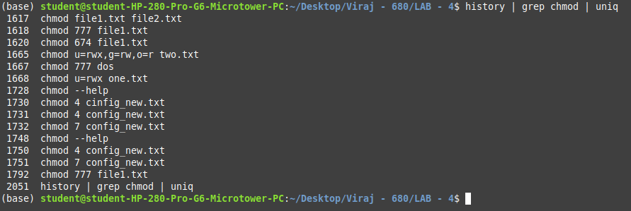

7. Display the first 10 lines of data.csv, then sort them in ascending order.

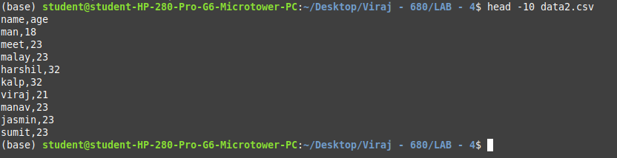

8. Replace all lowercase letters with uppercase in message.txt.

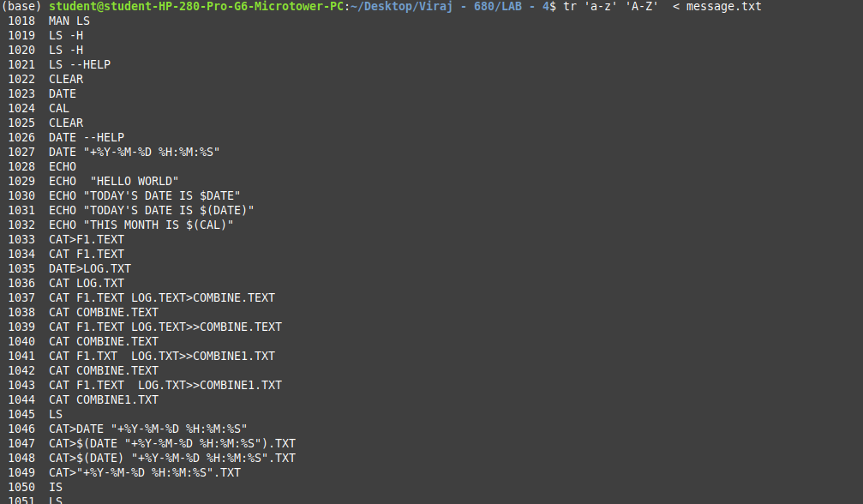

9. Find all files larger than 1MB in the current directory, add line numbers

